**READ Web Application User Manual**

**Table of Contents**

1. Introduction
2. Registration and Login
3. Reader User Guide
4. Teacher User Guide
5. Admin User Guide
6. Frequently Asked Questions
7. Troubleshooting

**1. Introduction**

Welcome to **READ**, a web application designed to help users improve their reading skills through interactive stories. Whether you are a **reader**, **teacher**, or **admin**, this manual will guide you through all the necessary steps to make the most of your experience.

**2. Registration and Login**

**2.1. Registration**

To create a new account:

1. Navigate to the registration page (/registration).
2. Select your role: **Reader** or **Teacher**.
3. Enter your **username**, **email address**, and **password**.
   * The password must follow a generic strong password structure.
   * The email must be valid.
4. Click **Submit**.
   * If there are any errors, such as an invalid email or a taken username, the system will notify you.

Figure : Example of Register Page

**2.2. Login**

Once registered:

1. Navigate to the login page (/login).
2. Enter your **username** and **password**.
3. Click **Log In**.
   * If your login credentials are incorrect, an error message will appear.

Figure : Example of Login Page

**3. Reader User Guide**

**3.1. Home Page**

After logging in, **Reader** users are redirected to the home page (/).

**User Summary**

At the top of the home page, you'll find three circles:

* **Center:** Your most recently read story, with progress indicated around the circle.
* **Right:** The total number of stories you've completed, with progress indicated around the circle.
* **Left:** Your current reading level, with progress indicated around the circle.

Below the summary, you will see several story carousels:

* **My List:** Stories you have saved.
* **Currently Reading:** Stories you are currently reading.
* **Difficulty Levels:** Stories organized by difficulty (Easy, Medium, Hard).

Hover over any story card to reveal the **story title**, **Read Story** button, and **Add to My List** button.

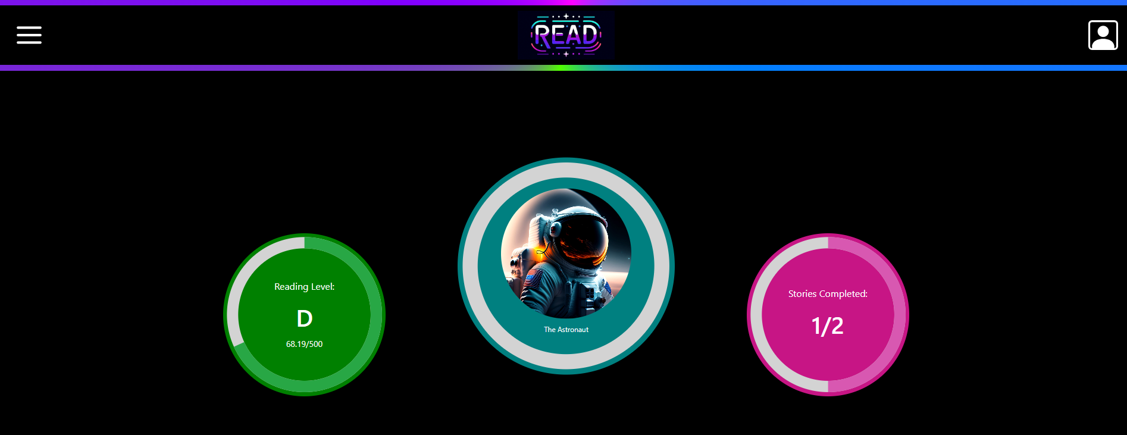

Figure : Example of User Home Page

Figure : Example of Story Carousel

**Header**

* **Settings (left):** Accessible via a hamburger menu, where you can modify account preferences and join a class.
* **Profile (right):** View or edit your profile, with an option to **sign out**.

Class

Figure 5:

**3.2. Reading a Story**

When you select **Read Story**, you are taken to the reader page (/story/{storyid}):

* The story text is displayed in a box, and your current position is automatically saved.
* **Highlighted Sentence:** The current sentence you need to read will be highlighted.
* **Buttons Available:**
  + **Mic Button:** Start recording your pronunciation for the current sentence, and the app will assess if it's correct.
  + **Previous Sentence:** Go back one sentence in the story.
  + **Start from Beginning:** Reset your progress to the start of the story.
  + **Show Stats:** Once you have completed a story, this button will appear, and render a pop-up indicating your progress, reading level increases and number of errors in the session.
  + **Complete Story:** Once you have completed a story, this button will appear. If you no longer need to view your session statistics, you may click this button to end the session and return to the home page.

Figure : Example of Story Reader

Figure : Example of Story Completion

Figure : Example of Session Statistics

**4. Teacher User Guide**

**4.1. Teacher Page**

Once logged in, **Teacher** users are directed to the teacher page (/teacher), where you can view your current classes and track students' progress.

Figure : Example of Teacher Page

*.*

**5. Admin User Guide**

**5.1. Admin Page**

As an **Admin**, you will have access to the admin page (/admin), where you can:

* **Manage Users:** View and update user details.
* **Manage Stories:** View, add, or update stories.
* **View Statistics:** View usage statistics for both users and stories.

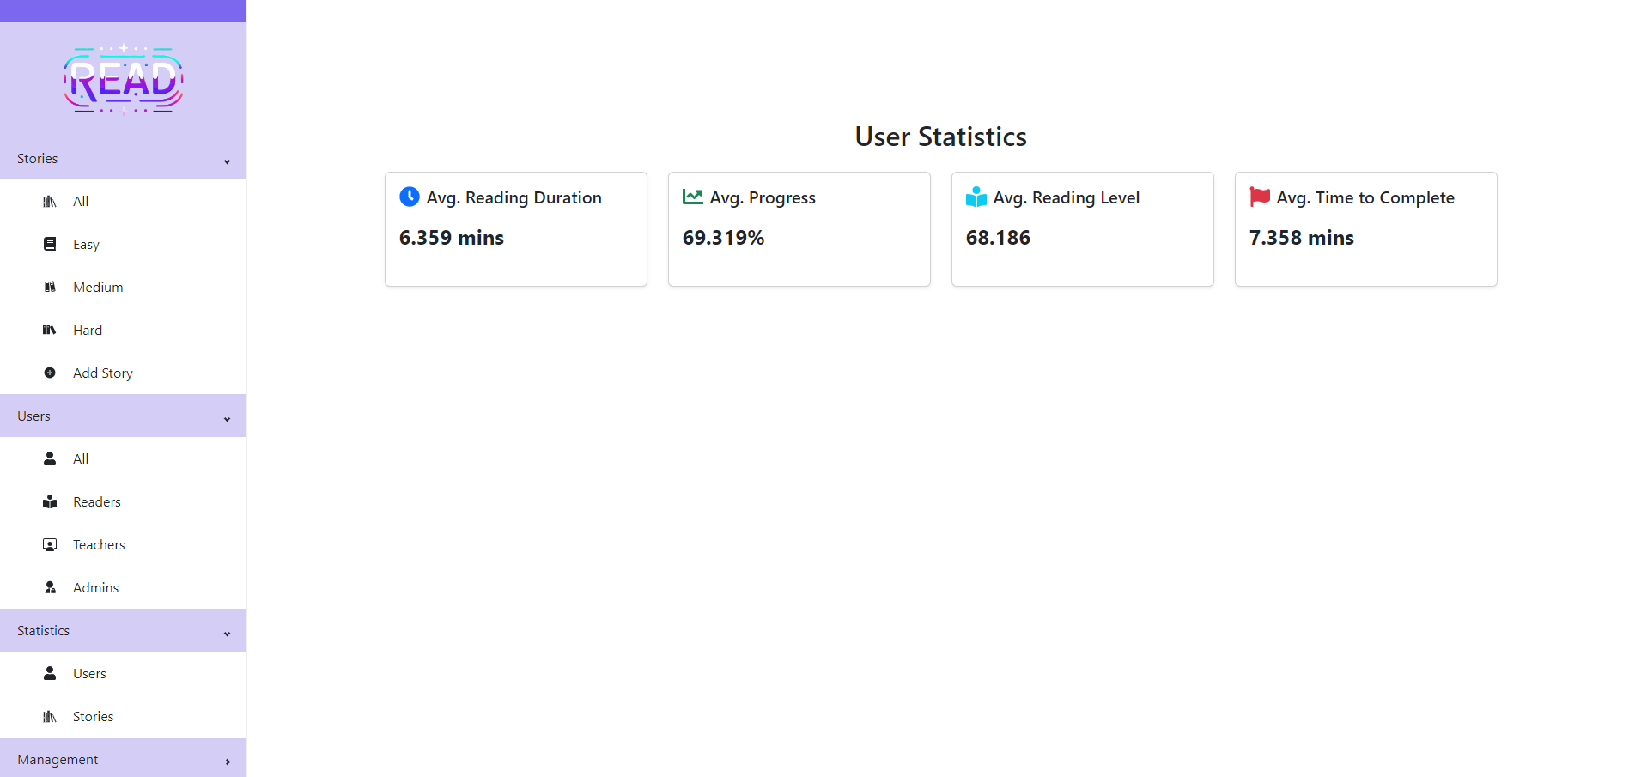

Figure : Example of Admin Page Functionality (User Statistics)

**6. Frequently Asked Questions**.

1. **How can I update my password?**
   * Go to the Profile section via the home page, enter your old and new passwords and select "Change Password."

*Leave space for additional FAQs.*

**7. Troubleshooting**

**Common Issues:**

* **Login Errors:** Double-check that your username and password are correct.
* **Story Progress Not Saving:** Ensure you have a stable internet connection while reading.

For further assistance, contact support.